School of Computer Science and Artificial Intelligence

Lab Assignment -3.2

Program :B. Tech (CSE)
Specialization :AIML
Course Title : AI Assisted Coding
Course Code : 23CS002PC304
Semester : VI
Academic Session : 2025-2026
Name of Student : P.Karthisha
Enrollment No. : 2303A52099
Batch No. : 33

Task Description-1
• Progressive Prompting for Calculator Design: Ask the AI to design a simple calculator
program by initially providing only the function name. Gradually enhance the prompt by
adding comments and usage examples.
Expected Output-1
• Comparison showing improvement in AI-generated calculator logic and structure.
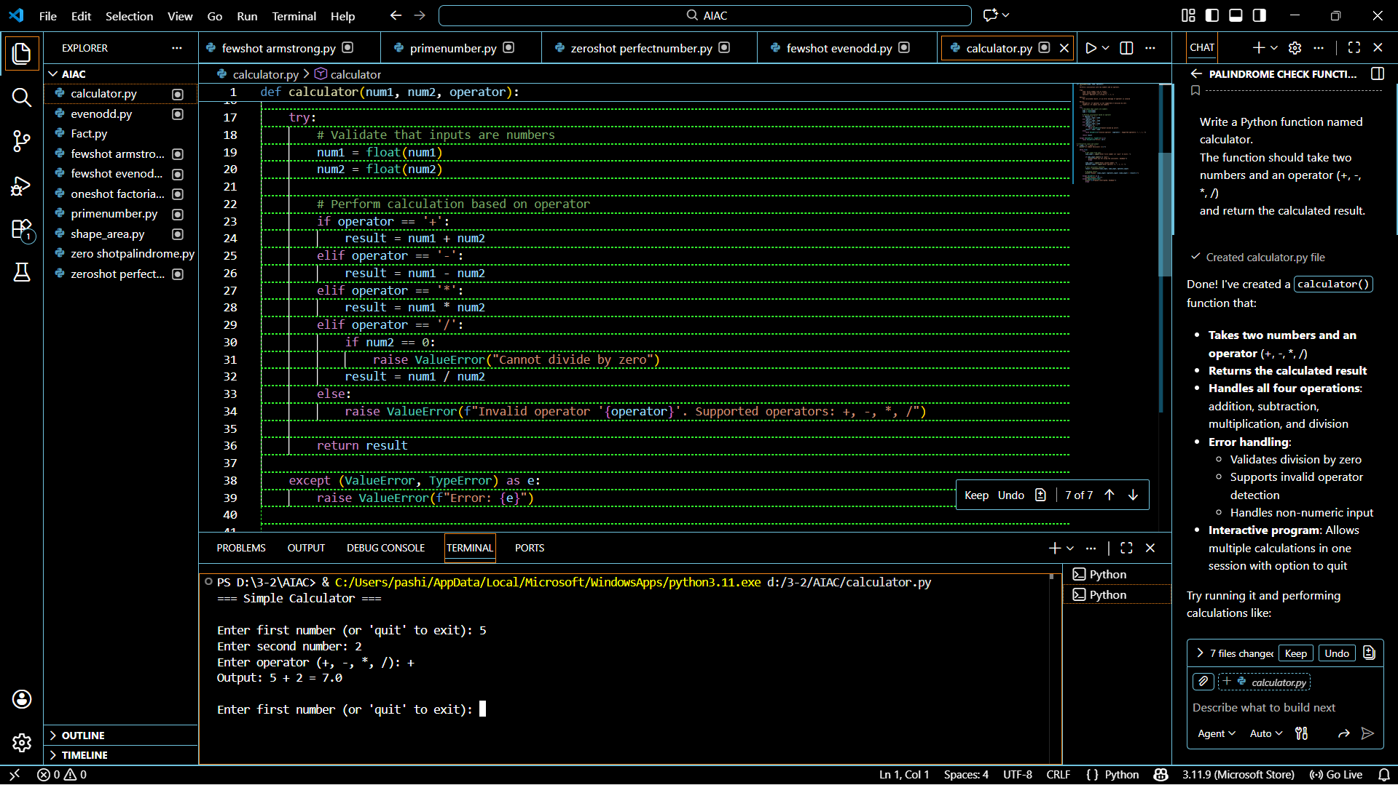
Task Description-2
• Refining Prompts for Sorting Logic: Start with a vague prompt for sorting student marks,
then refine it to clearly specify sorting order and constraints.
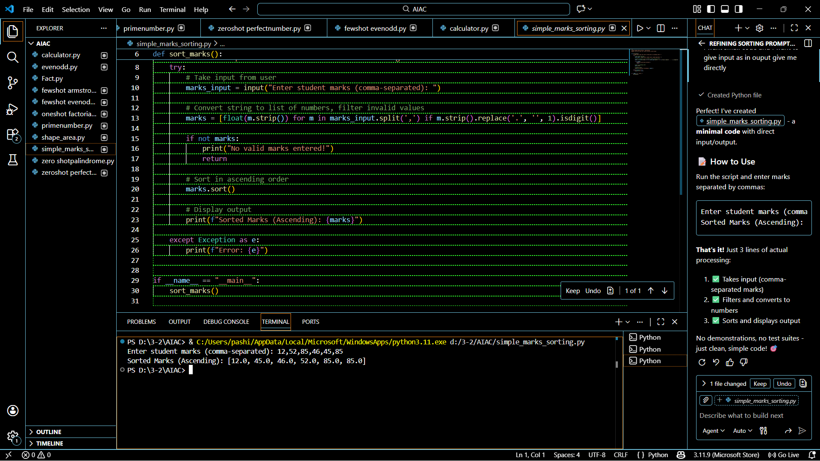
Task Description-3
• Few-Shot Prompting for Prime Number Validation: Provide multiple input-output
examples for a function that checks whether a number is prime. Observe how few-shot
prompting improves correctness.

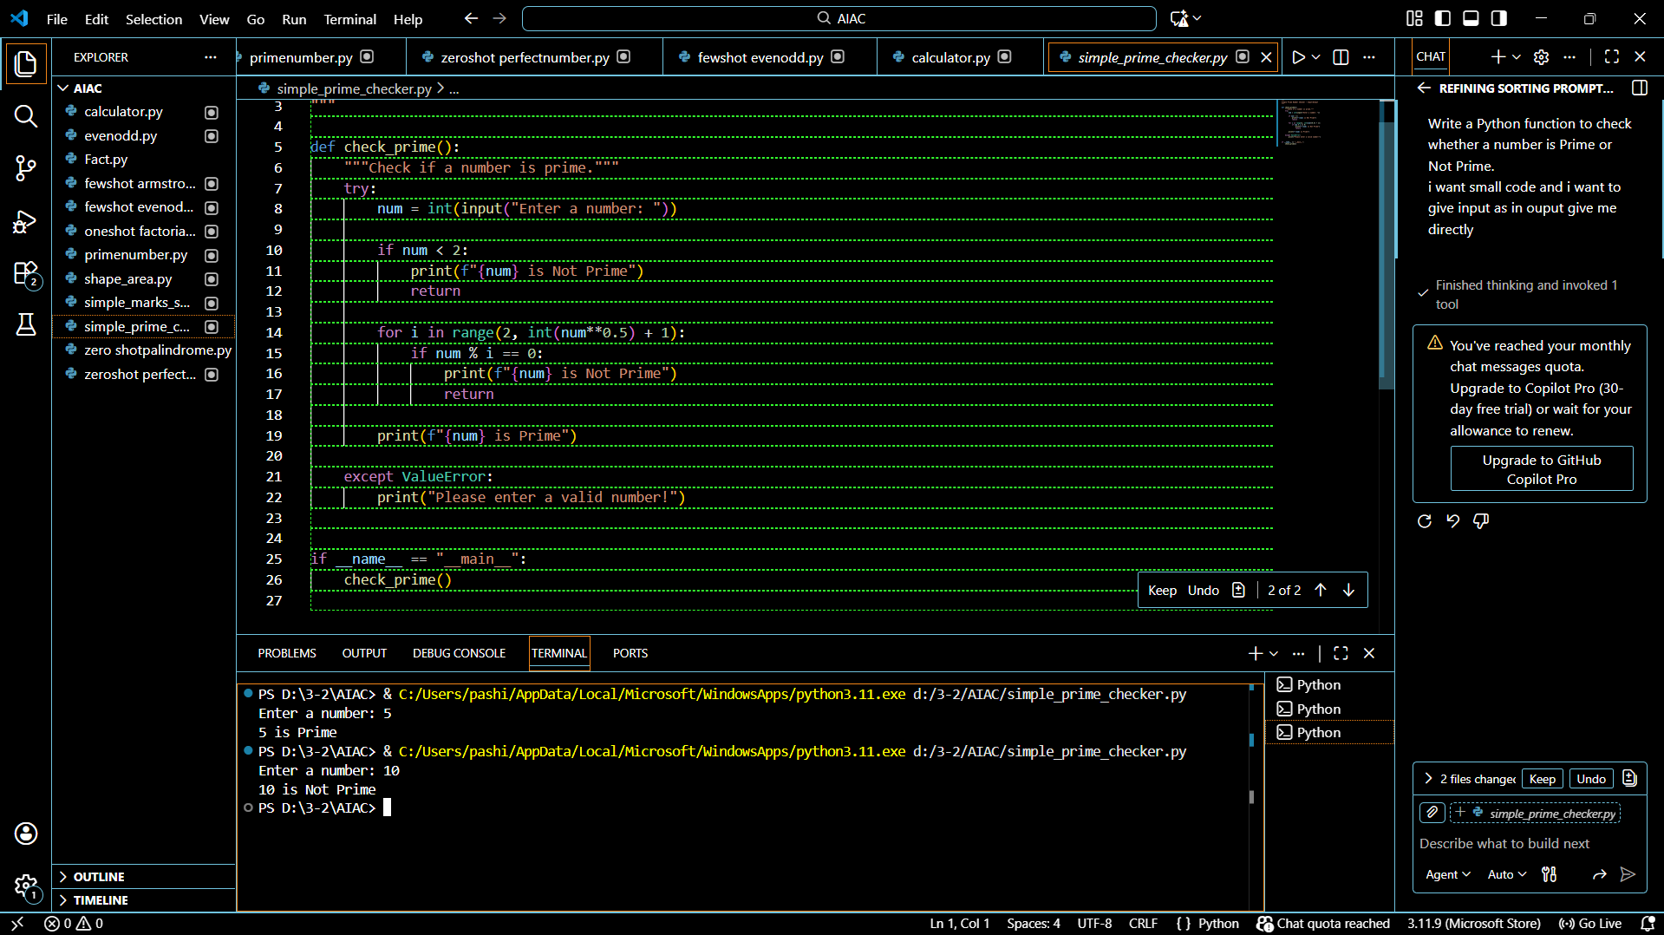

Task Description-4
• Prompt-Guided UI Design for Student Grading System: Create a user interface for a
student grading system that calculates total marks, percentage, and grade based on user
input.
Task Description-5
• Analyzing Prompt Specificity in Unit Conversion Functions: Improving a Unit
Conversion Function (Kilometers to Miles and Miles to Kilometers) Using Clear
Instructions.

